**Task No. 1:** Switches Named As: A, B, C, D And Connect Them in Alphabetical Order. Perform And Show the Following Configurations In Your Lab Task.

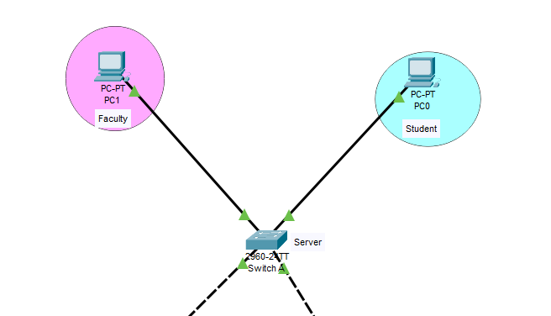A. Switch A With Vlans Faculty and Students Having 1 Logical Port Each.

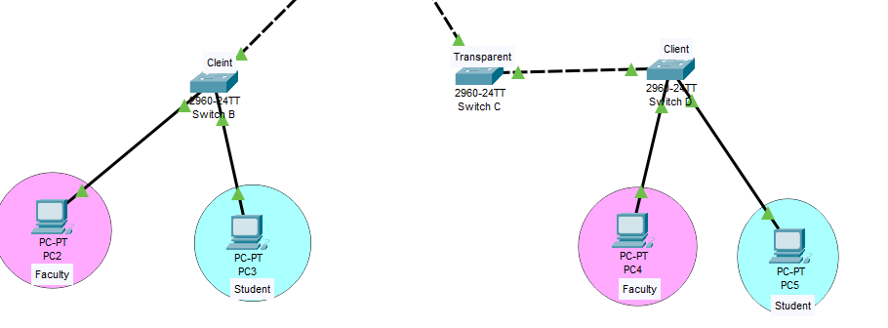b. Now assign 1 logical port each to VLANs faculty and students in Switch B and D.

c. Now make switch A in server mode, whereas B and D in client mode and switch C in transparent mode.

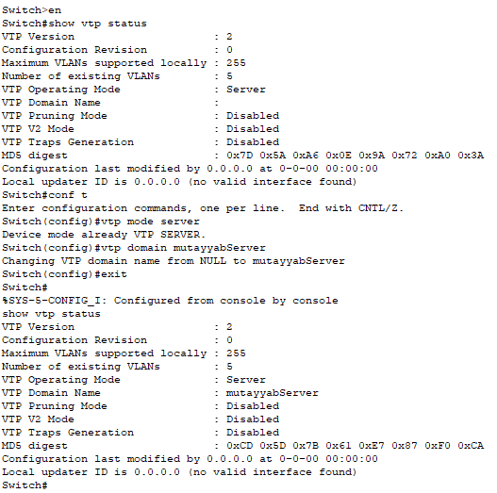

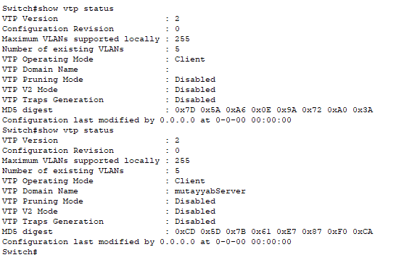

Switch B

Switch A

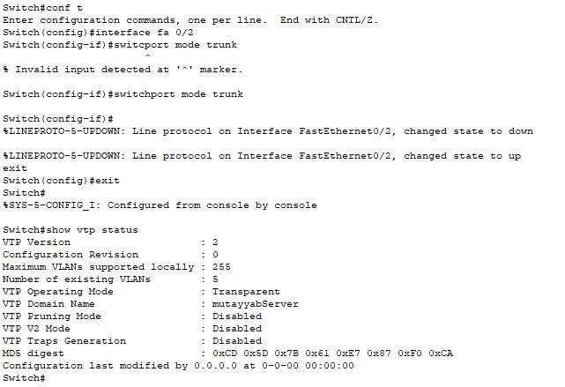

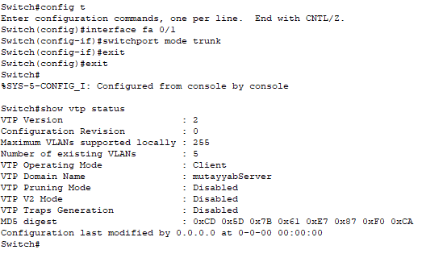

Switch D

Switch C

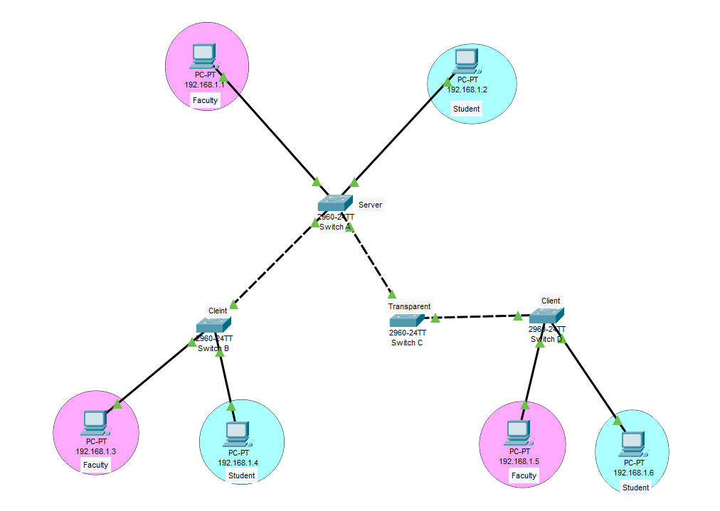d. Assign IP addresses to PCs connected to Switch A, B and D.

|  |  |
| --- | --- |
| PC Name | IP |
| PC1 | 192.168.1.1 |
| PC2 | 192.168.1.2 |
| PC3 | 192.168.1.3 |
| PC4 | 192.168.1.4 |
| PC5 | 192.168.1.5 |
| PC6 | 192.168.1.6 |

e. Now ping within the same VLAN and outside the same VLAN and show your results.

From To

1. 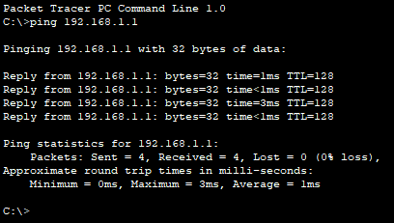Client 1 (Faculty) => Server (Faculty) ping
2. 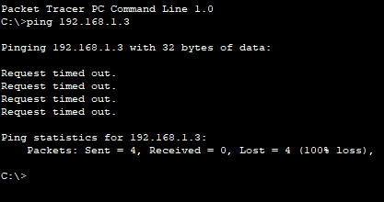Client 1 (Student) => Client 1(Faculty) failed
3. 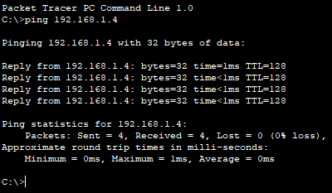Server (Student) => Client 1(Student) ping
4. 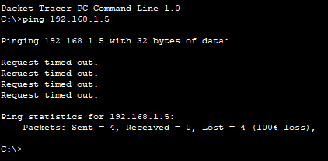Anywhere (Student) => Client 2 failed